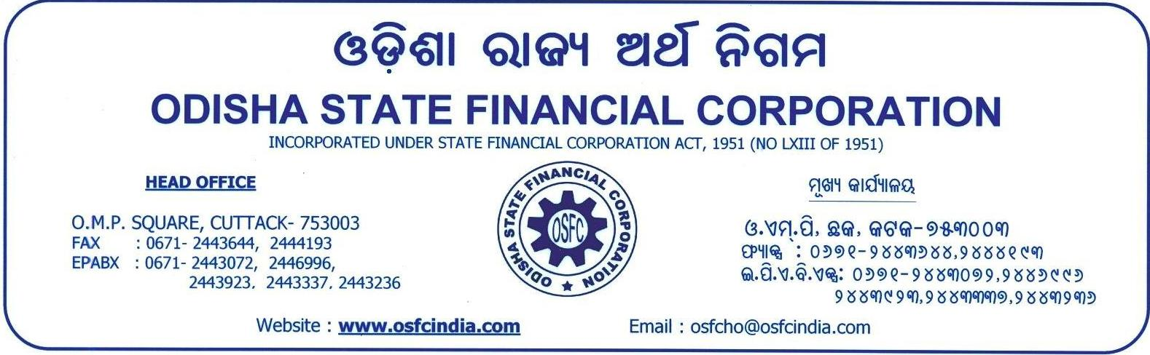

No.OSFC / 2521015 /02 / 2026-27
July 09, 2026

N O T I C E

QUOTATION FOR COMPREHENSIVE ANNUAL MAINTENANCE CONTRACT (AMC) OF COMPUTER EQUIPMENTS

Sealed quotations are invited for comprehensive Annual Maintenance Contract (AMC) for computer equipments installed in various offices of OSFC within Odisha as per the enclosed list. The details of items, standard AMC agreement conditions are available in the website of OSFC (www.osfcindia.com) under the Sale & Purchase menu.

The quotation mentioning total cost and disagreed conditions, if any, should reach the undersigned item-wise on or before July 20, 2026 at 5 P.M. in Computer Services Department of OSFC, O.M.P. Square, Cuttack-753003. However, the Corporation reserves the right to reject the quotation without assigning any reason whatsoever.

Yours faithfully,

Sd/-
ACCOUNT CONSULTANT

Memo No.OSFC / 2521015 / /2026-27
Juy 09-, 2026

Copy to Notice Board of HO and all BOs / Website of OSFC
Annexure-I -Computer Equipments to be covered under Annual Maintenance Contract (AMC)
Annexure-II -Standard AMC Agreement format
of OSFC with conditions
Sd/-
ACCOUNT CONSULTANT

